Accessing DVWA:

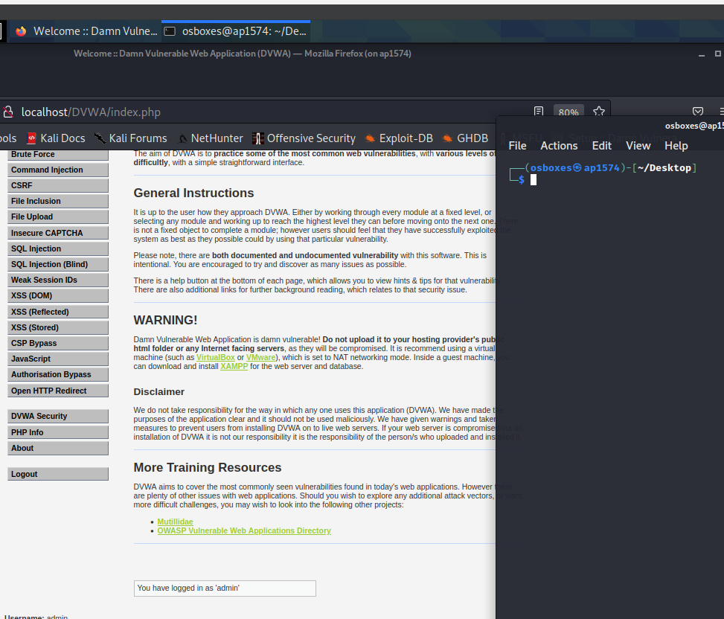

Installed and configured the dvwa in my kali linux machine.

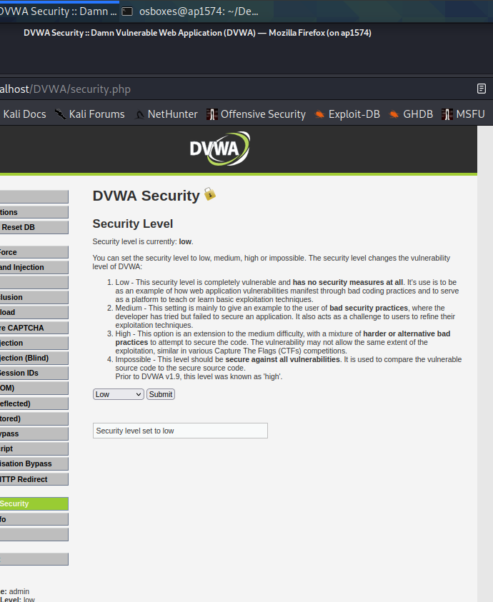

Making sure that security level is set to low level.

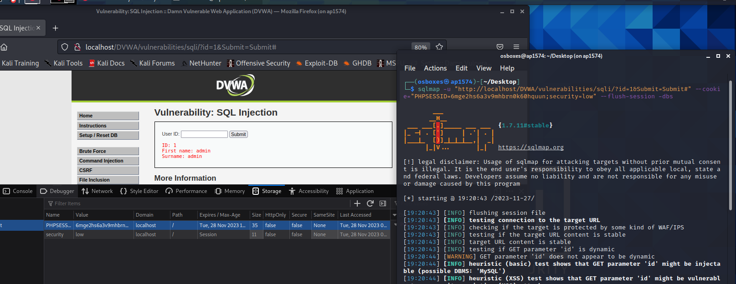

Trying sqlmap to get connection to the dvma.

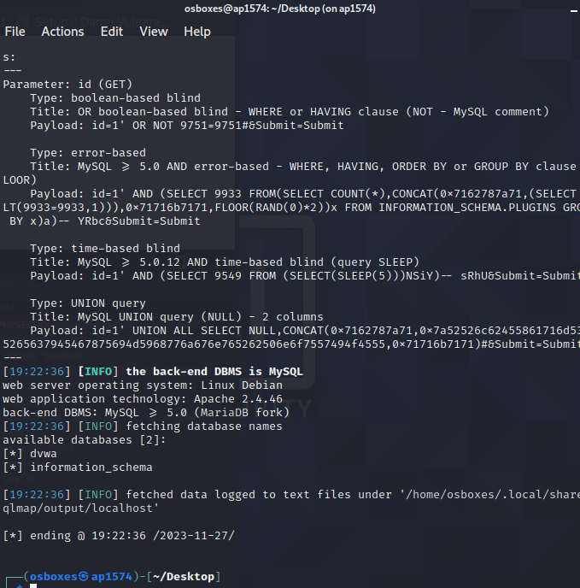

We are able to get the details on the database using sqlmap on low mode.

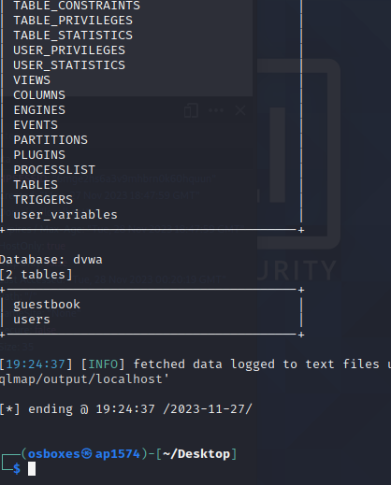

The above screenshot shows the list of tables on the database.

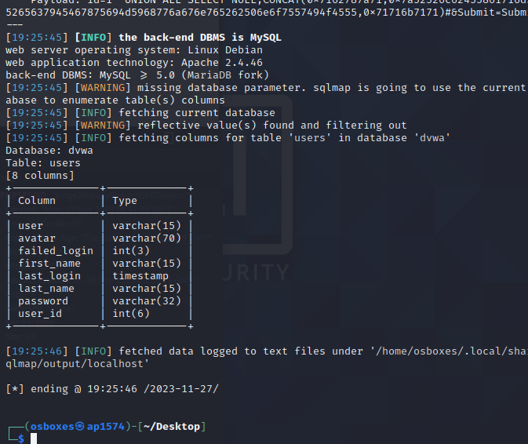

Here is the list of columns of the table on users in the dvwa database.

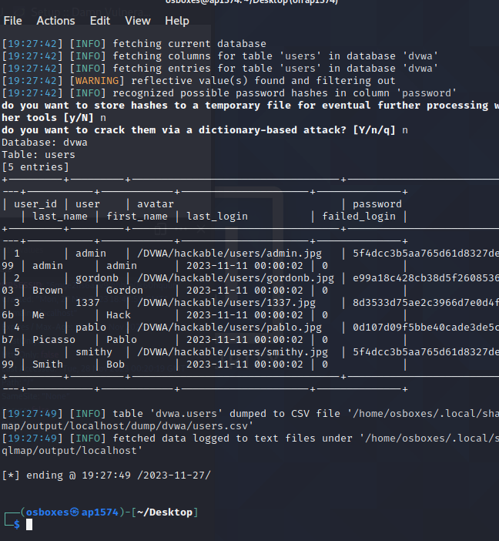

Here is the data on the table, Now I will be try cracking the passwords hash to get the passwords.

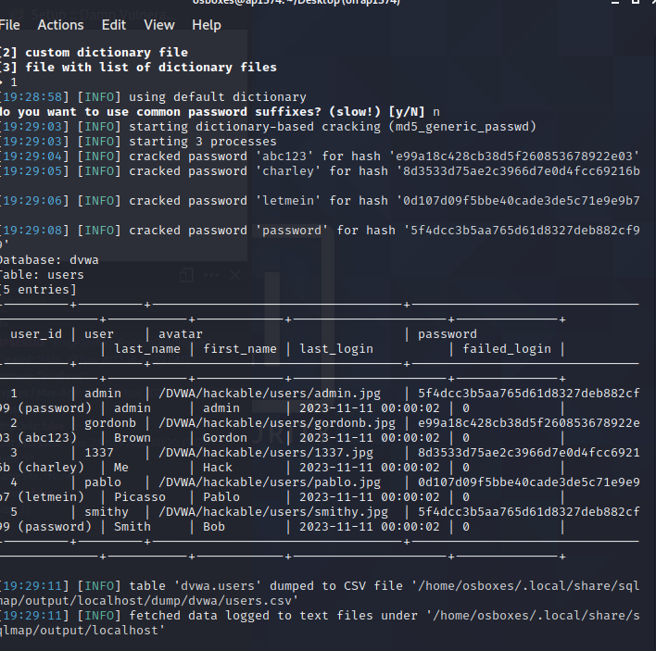

We can see in the table, the calculated hash values of the passwords in it.

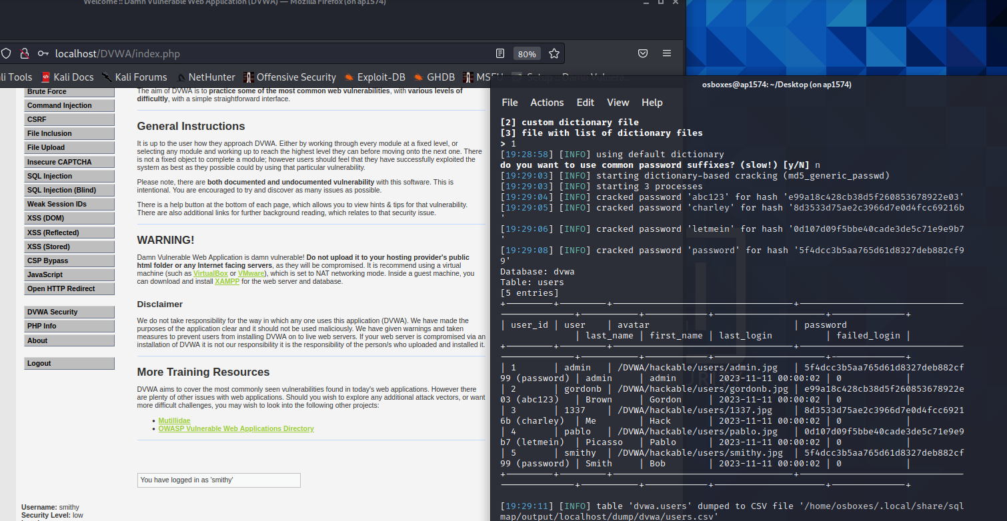

We can see, I was able to get login as smithy with the password we got from sqlmap.

Part -2:

When I tried using the same command and changing the security level to medium and high. I got the same result. I wasn’t able to get the login details

